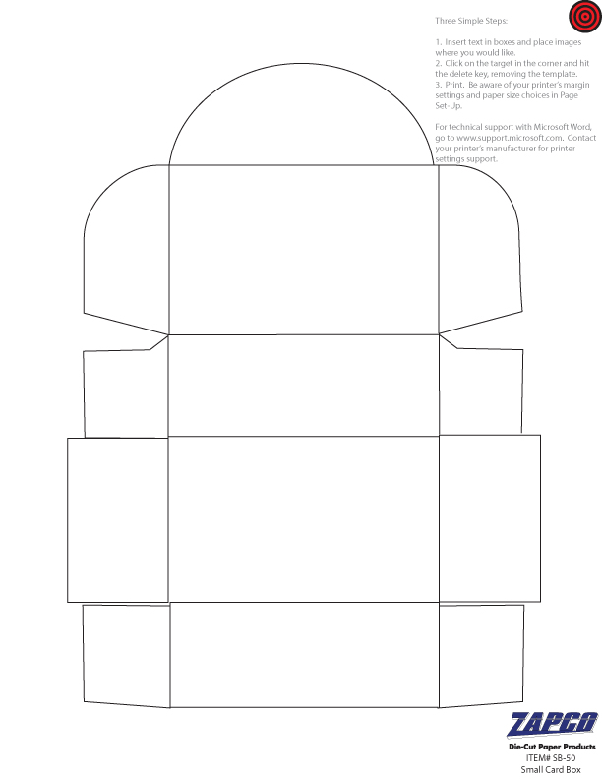

Enter Text and Pictures for TOP of Box here. Continue to add artwork to the remaining sides as you see fit.