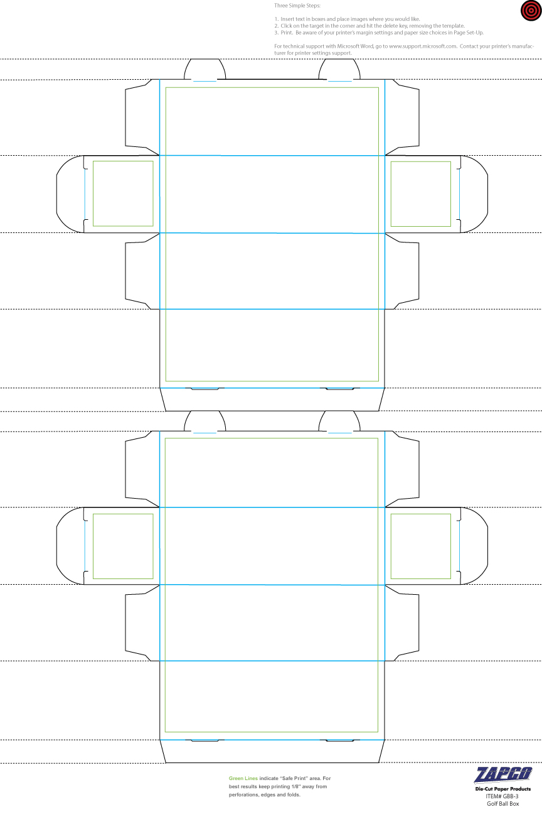

Enter Pictures and text in boxes such as this one. Copy and paste them into the designated areas within the die-lines. Be aware of the direction of the sides once the box is assembled before you print.

Enter Pictures and text in boxes such as this one. Copy and paste them into the designated areas within the die-lines. Be aware of the direction of your artwork on all sides of the box before you print.