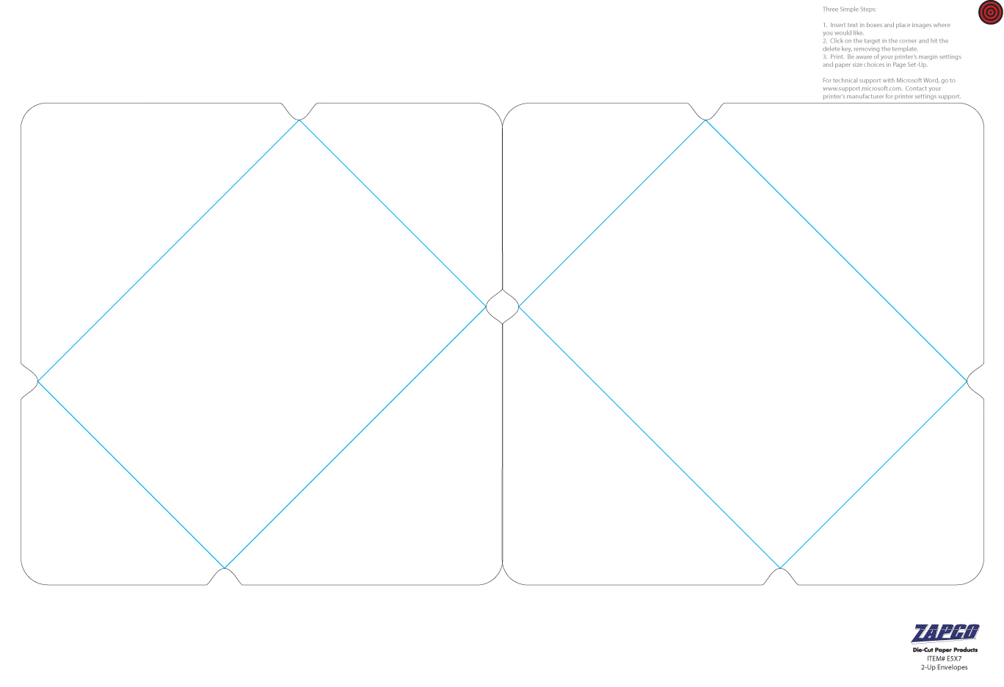

Enter Text or images HERE.

Enter Text or images HERE.