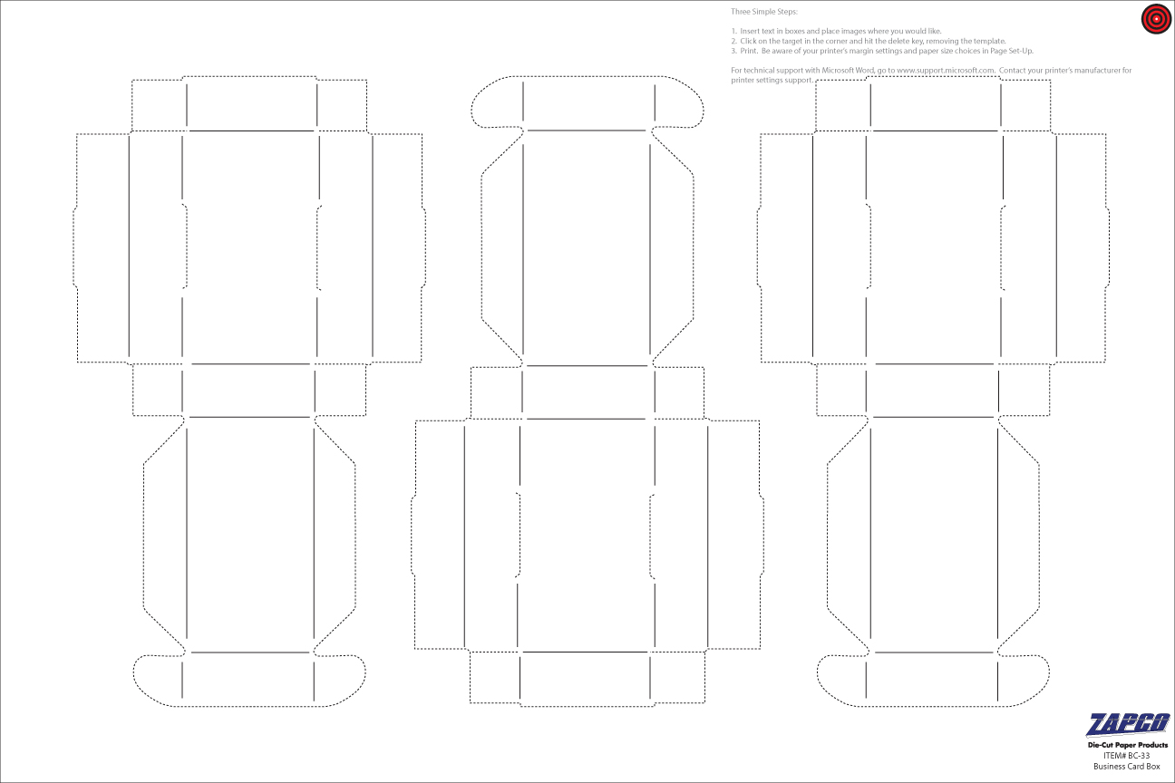

BOX Front Flap

BOX TOP

Box Side

Box Side

Bottom Of Box